
Applied Software Project Report

By

Sumit Pal

A Master’s Project Report submitted to Scaler Neovarsity - Woolf in partial fulfillment of the requirements for the degree of Master of Science in Computer Science

September 2026

Scaler Mentee Email ID : palsumeeth@gmail.com
Thesis Supervisor : Naman Bhalla
Date of Submission : 30/09/2026

Certification

I confirm that I have overseen / reviewed this applied project and, in my judgment, it adheres to the appropriate standards of academic presentation. I believe it satisfactorily meets the criteria, in terms of both quality and breadth, to serve as an applied project report for the attainment of Master of Science in Computer Science degree. This applied project report has been submitted to Woolf and is deemed sufficient to fulfill the prerequisites for the Master of Science in Computer Science degree.

Naman Bhalla
…………………
Project Guide / Supervisor

DECLARATION

I confirm that this project report, submitted to fulfill the requirements for the Master of Science in Computer Science degree, completed by me from 01/09/2026 to 24/09/2026, is the result of my own individual endeavor. The Project has been made on my own under the guidance of my supervisor with proper acknowledgement and without plagiarism. Any contributions from external sources or individuals, including the use of AI tools, are appropriately acknowledged through citation. By making this declaration, I acknowledge that any violation of this statement constitutes academic misconduct. I understand that such misconduct may lead to expulsion from the program and/or disqualification from receiving the degree.

Sumit Pal


Signature of the Candidate Date: 30 September 2026

ACKNOWLEDGMENT

I would like to express my heartfelt gratitude to my family for their constant support, patience, and encouragement throughout this journey. Their belief in me kept me motivated during challenging times. I am deeply thankful to the Scaler instructors and mentors for their exceptional guidance, practical insights, and dedication to teaching, which played a crucial role in shaping my understanding and skills. I also extend my appreciation to all those who, in one way or another, inspired, supported, and motivated me to stay committed and successfully complete this program and earn my Master’s degree.

Table of Contents

List of Tables 6
List of Figures 7
Applied Software Project 8
Abstract 8
Project Description 8
1. Requirement Gathering 9
2. Class Diagrams 15
3. Database Schema Design 18
4. Feature Development Process 24
5. Deployment Flow 28
6. Technologies Used 30
7. Conclusion 31
References 32

List of Tables

Table No. | Title | Page No.
Table 1.1 | Functional requirements and implementation coverage | 9
Table 1.2 | Non-functional requirements | 10
Table 1.3 | Actors and use cases | 10
Table 1.4 | Feature set and API coverage | 11
Table 2.1 | Core domain classes and responsibilities | 12
Table 3.1 | Service-owned persistence stores | 13
Table 3.2 | User service relational schema | 13
Table 3.3 | Product catalog relational schema | 14
Table 3.4 | Order, payment, and notification schemas | 14
Table 3.5 | Cardinality and ownership relationships | 15
Table 4.1 | Password-reset API contract | 16
Table 4.2 | Password-reset validation and security controls | 17
Table 5.1 | Runtime components and ports | 18
Table 5.2 | Technology stack and project usage | 19

List of Figures

Figure No. | Title | Page No.
Figure 1.1 | Capstone project development process | 8
Figure 1.2 | Backend use-case diagram | 11
Figure 2.1 | Logical class diagram of the ecommerce domain | 12
Figure 3.1 | Logical entity-relationship diagram across service-owned stores | 15
Figure 4.1 | Password-reset request and confirmation sequence | 16
Figure 5.1 | Local deployment and event flow | 18

Applied Software Project

Abstract
Ecommerce Platform is a backend-focused ecommerce system implemented as a set of Spring Boot microservices. It supports account registration, password and Google login, profile management, secure password reset, category and product management, keyword search, cart operations, checkout, order history, payment initialization through Stripe or Razorpay, payment webhooks, and email notification.
The solution separates business capabilities into User Management, Product Catalog, Cart, Order, Payment, Email Notification, and Service Discovery components. HTTP APIs are used where an immediate client response is required, while Apache Kafka is used for asynchronous facts such as welcome emails, password-reset emails, order placement, and payment confirmation. PostgreSQL stores structured business records, MongoDB stores cart documents, Redis is configured for the cart access path, and Elasticsearch provides product keyword search. Because the project is backend-only, its public APIs can be verified through Postman, curl, or a similar REST client; no storefront user interface is required to validate the core business flows.
The report distinguishes the planned high-level architecture from the running implementation. PostgreSQL is used instead of the MySQL named in the original PRD, Gmail SMTP is used instead of Amazon SES, and the designed Kong gateway and AWS load balancer are future deployment components rather than currently deployed services.

Project Description
The project implements the backend of an online retail platform in which a shopper can create an account, discover products, maintain a cart, place an order, complete payment through a provider, and receive email confirmation. The central engineering problem is to keep these business functions independently maintainable while preserving a coherent end-to-end purchase flow.
The project therefore uses service boundaries that mirror the business domains. The User Service owns identity and credentials; the Product Catalog Service owns categories, products, and search indexing; the Cart Service owns cart documents; the Order Service owns order creation and status; the Payment Service owns provider transactions and webhook confirmation; and the Email Service consumes business events and sends mail. A service owns its own persistence store rather than directly reading another service's tables.
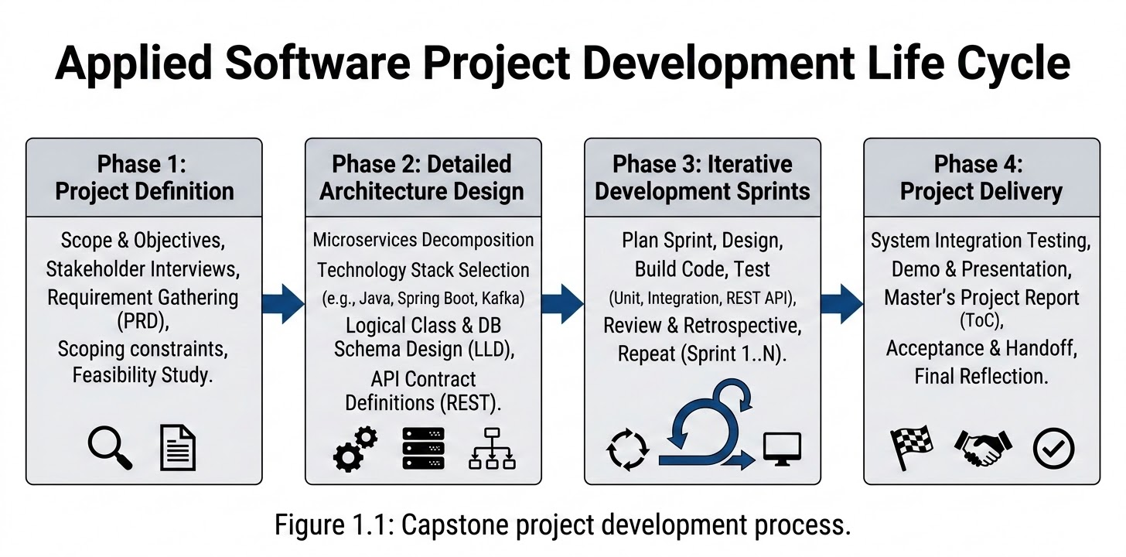
Figure 1.1: Capstone project development process. The project followed the required stages of definition, planning, development through iterative sprints, and delivery through demonstration, reflection, and report submission.

1. Requirement Gathering
1.1 Requirement analysis
The PRD defines six functional domains: User Management, Product Catalog, Cart and Checkout, Order Management, Payment, and Authentication. The implementation maps these areas to independently deployable Spring Boot services and uses Kafka for events that should not block the original request, especially email and payment-related reactions.
The backend is validated through REST APIs. A test client such as Postman can register users, acquire tokens, create products and categories, update a cart, place an order, initialize payment, invoke provider-webhook test flows, and inspect notification records. This is appropriate because the repository contains backend services rather than a browser or mobile storefront.
1.1.1 Functional requirements
Table 1.1: Functional requirements and implementation coverage.
Area | PRD requirement | Implemented backend behaviour | Representative API or event
User management | Register with email or social identity | Email/password registration and Google identity login create or resolve a user | POST /user-mgmt/api/v1/users, POST /user-mgmt/api/v1/auth/login/google
User management | Secure login | Password is verified with BCrypt; access and refresh tokens are issued | POST /user-mgmt/api/v1/auth/login/password
User management | Profile management | Authenticated user can read and update their profile | GET, PUT /user-mgmt/api/v1/profile/me
User management | Password reset | One-hour reset token is hashed before persistence and sent by Kafka-triggered email | POST /user-mgmt/api/v1/password/reset, POST /user-mgmt/api/v1/password/confirm
Product catalog | Browse by category | Create/list categories and list products by category | POST, GET /product-catalog/categories; GET /product-catalog/products/category/{categoryId}
Product catalog | Product detail | Return catalog record for a product | GET /product-catalog/products/{id}
Product catalog | Keyword search | Query a derived Elasticsearch index | GET /product-catalog/products/search
Cart and checkout | Add, review, update, remove cart lines | Persist a cart document with item-level changes | POST, GET, PUT, DELETE /api/v1/cart/...
Order management | Checkout and confirmation | Persist an order and publish an order.placed event | POST /api/v1/orders/checkout; Kafka order.placed
Order management | Order history and status | Fetch a single order, list by user, and patch status | GET /api/v1/orders/{orderId}, GET /api/v1/orders?userId=, PATCH /api/v1/orders/{orderId}/status
Payment | More than one payment method | Stripe and Razorpay initialization paths are supported | POST /v1/payment/initialize
Payment | Secure confirmation and receipt | Stripe/Razorpay webhook signatures are verified; payment confirmation is published | POST /webhook/stripe, POST /webhook/razorpay, GET /v1/payment/receipt/{orderId}
Authentication | Session and logout management | JWT access token, stored hashed refresh token, token refresh, and revocation on logout | POST /user-mgmt/api/v1/auth/refresh, POST /user-mgmt/api/v1/auth/logout
Notification | Confirmation and receipt messages | Email consumer processes registration/reset, order, and payment events | Kafka emailservice, order.placed, payment.confirmed

1.1.2 Non-functional requirements
Table 1.2: Non-functional requirements.
Requirement | Design approach in the project | Current status and constraints
Modularity | One Maven/Spring Boot module per service | Implemented for user, catalog, cart, order, payment, email, and discovery
Independent data ownership | Separate PostgreSQL databases per relational service; MongoDB for carts | Implemented; services should not directly share tables
Responsiveness | Elasticsearch for search; Redis configured for cart fast access | Search is implemented as a derived read model; cart caching policy should be documented further
Asynchronous processing | Kafka topics decouple email and payment reactions from the initiating request | Implemented for email, order placement, and payment confirmation
Security | BCrypt passwords, HMAC-hashed reset/refresh tokens, JWT access tokens, signature-verified webhooks | Implemented in the core flows; secrets must be externally managed in production
Reliability | Consumer groups and persistent business records | A production implementation should additionally provide retries, dead-letter topics, idempotency, and transactional outbox publishing
Scalability | Services can be scaled separately according to workload | Architectural capability exists; gateway, load balancer, and service registration are not yet deployed
Observability | Database logs and service-level tests are present | Centralized logs, tracing, and production metrics are future improvements
API usability | Versioned REST routes and Postman collection for main flows | Implemented, though route conventions vary across services
Testability | JUnit/Spring Boot tests and Postman-based manual verification | Implemented; no repository-wide coverage percentage is claimed
1.2 Users and use cases
The project has both human and external-system actors. The Shopper is the main API consumer. Catalog and order operators represent authorized back-office users or test operators who call management APIs. Stripe and Razorpay are external payment systems that call webhook endpoints. Gmail SMTP is an external delivery system used by the Email Service.
Table 1.3: Actors and use cases.
Actor | Main goals | Backend interactions
Shopper | Create account, authenticate, browse, search, maintain cart, purchase, view orders | Calls user, catalog, cart, order, and payment APIs using Postman or a future frontend
Catalog operator | Maintain categories and products | Calls category and product write APIs
Order operator | Progress an order through operational statuses | Calls the order-status patch endpoint
Payment provider | Confirm a provider-side payment result | Calls Stripe or Razorpay webhook endpoint with signature
Email provider | Deliver outgoing messages | Receives SMTP requests from Email Service
Notification service | Inform user of important events | Consumes Kafka messages and records delivery attempts

Flowchart LR
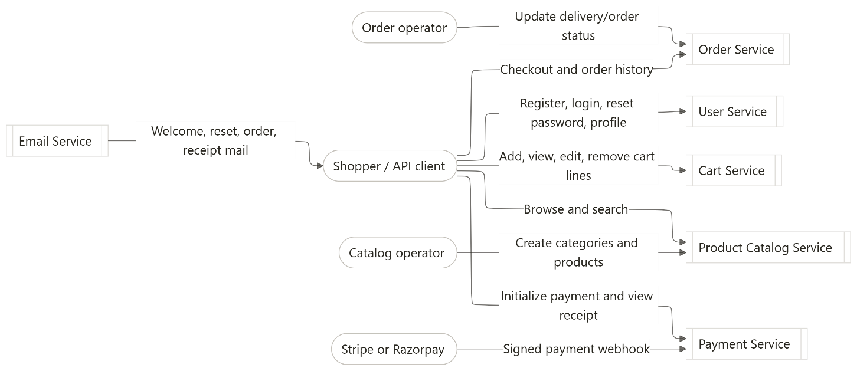

Figure 1.2: Backend use-case diagram. The shopper is represented as an API client because the submitted system is backend-only; Postman or a comparable REST client can execute the listed use cases.

1.3 Feature set
Table 1.4: Feature set and API coverage.
Feature | User value | Backend service | Validation approach using Postman or similar tool
Email registration | Create an account | User Service | Send POST /user-mgmt/api/v1/users; verify response tokens, user record, and welcome-email event
Password login | Access protected operations | User Service | Send login request; use returned bearer token in protected requests
Google login | Sign in with external identity | User Service | Submit valid Google token in the Google-login request
Refresh/logout | Maintain or end session | User Service | Refresh an expired/near-expired session; logout and verify refresh token cannot be reused
Profile read/update | Manage account details | User Service | Use bearer token with GET and PUT /profile/me
Password reset | Recover account securely | User Service and Email Service | Request reset; obtain test reset link/token; confirm; verify old password fails and new password succeeds
Category management | Organize products | Product Catalog Service | Create category, then list categories
Product management | Add product information | Product Catalog Service | Create product and retrieve it by id
Product search | Find products by keyword | Product Catalog Service and Elasticsearch | Search for indexed product terms; verify search response
Cart management | Build a prospective purchase | Cart Service | Add item, fetch cart, change quantity, remove item
Checkout | Create an order | Order Service | Submit checkout request; verify order response and order.placed processing
Order history/status | View and operate orders | Order Service | Fetch by id, list by user, patch status
Payment initialization | Obtain provider payment link/transaction | Payment Service | Submit initialize request using Stripe or Razorpay mode
Payment confirmation | Finalize a verified payment | Payment Service | Use provider test tooling or signed webhook payload; verify payment.confirmed reaction
Notification log | Inspect outbound notification attempts | Email Service | Call GET /notifications and verify notification records

2. Class Diagrams
2.1 Low-level design approach
The low-level design is split by service ownership. This is important: the diagram is a logical domain model, not a statement that every entity belongs to one shared database. In the actual microservice implementation, the User Service, Catalog Service, Cart Service, Order Service, Payment Service, and Email Service persist their own records separately. Cross-service identifiers, such as userId, productId, and orderId, are values exchanged by APIs or Kafka events rather than relational foreign keys across database boundaries.
The central model contains a user/account aggregate, catalog aggregate, cart document aggregate, order aggregate, payment aggregate, and notification aggregate. The PRD's desired model includes delivery tracking. The current implementation exposes an order status update but does not yet integrate a carrier or persist a full shipment-tracking domain; it is therefore shown as a planned extension rather than a confirmed implemented table.

Table 2.1: Core domain classes and responsibilities.
Class or document | Key fields | Responsibility | Service owner
User | id, email, passwordHash, status, createdAt | Account identity and local credentials | User Service
UserIdentity | id, userId, provider, providerSubject | External identity mapping, such as Google | User Service
UserMetadata | id, userId, profile attributes | Additional user/profile metadata | User Service
RefreshToken | id, userId, tokenHash, expiresAt, revoked | Revocable session continuation | User Service
PasswordResetToken | id, userId, tokenHash, expiresAt, used | One-time password recovery | User Service
Category | id, name, description | Product grouping | Product Catalog Service
Product | id, categoryId, name, description, price, stock, state | Sellable catalog record | Product Catalog Service
Cart | id, userId, items, timestamps | User's active mutable cart document | Cart Service
CartItem | itemId, productId, quantity, price snapshot | One selected cart line | Cart Service, embedded in cart
Order | id, userId, status, total, timestamps | Purchase record and order lifecycle | Order Service
OrderItem | id, orderId, productId, quantity, unitPrice | Immutable line snapshot inside an order | Order Service
PaymentTransaction | id, orderId, provider, providerReference, amount, status | Provider payment lifecycle and audit trail | Payment Service
NotificationLog | id, recipient, type, status, createdAt | Record of notification attempt | Email Service
ShipmentTracking | id, orderId, carrier, trackingNumber, status | Future detailed logistics tracking | Planned extension

Class Diagram 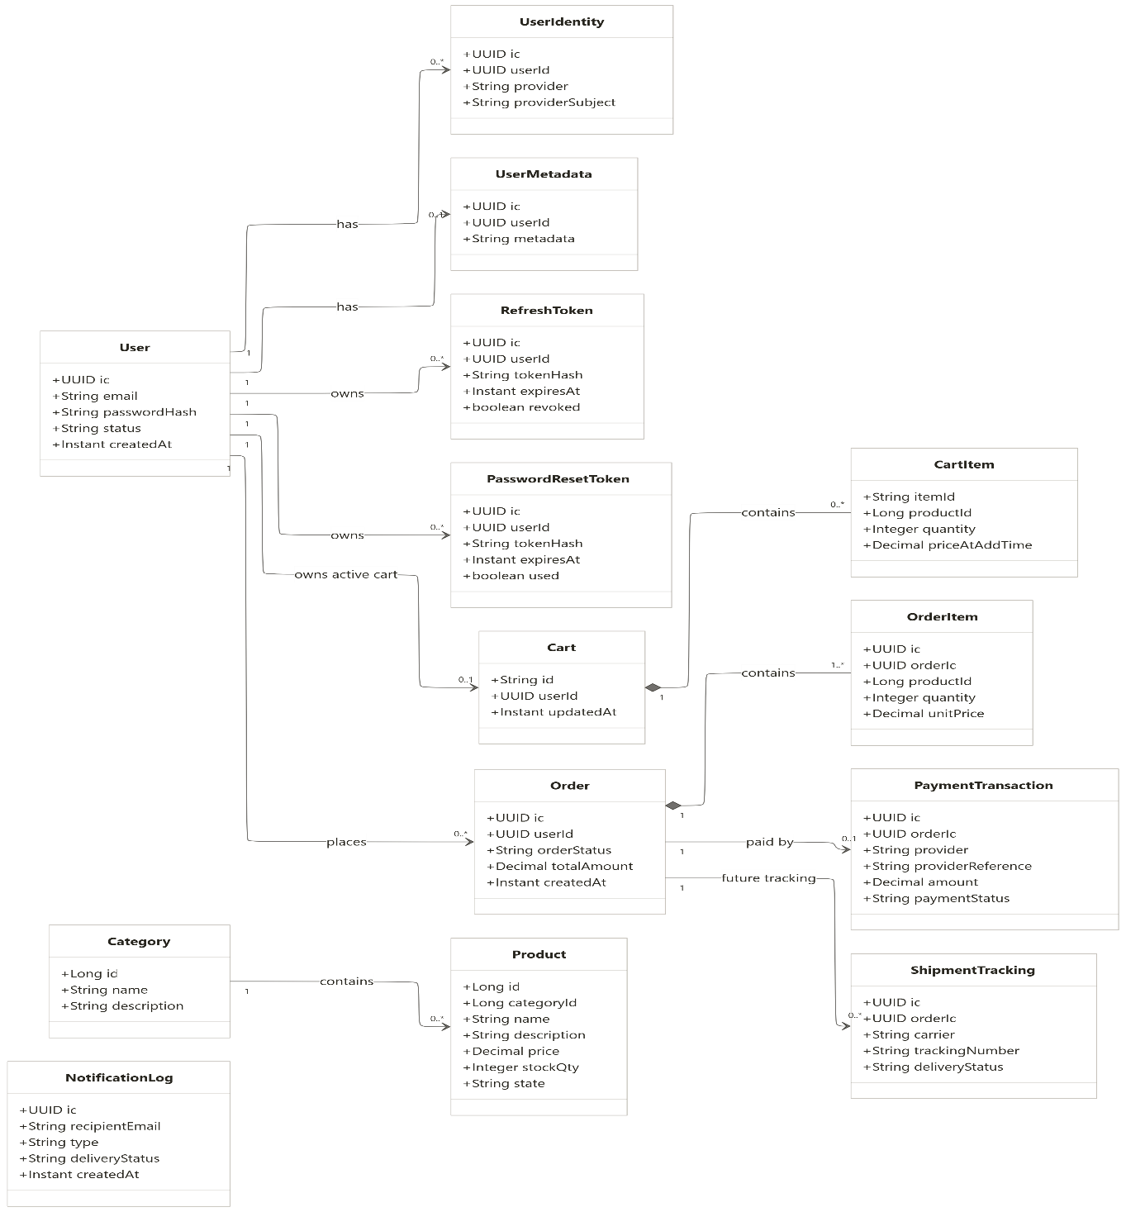
Figure 2.1: Logical class diagram of the ecommerce domain. Solid composition is used for line items because cart items and order items have no independent meaning without their parent aggregate. Relationships across service-owned databases are logical identifier relationships, not database foreign keys.
2.2 Key relationships
- One User can have many UserIdentity, RefreshToken, and PasswordResetToken records.
- One User has zero or one UserMetadata record in the documented current user model. The report template calls this UserProfile; UserMetadata is the implementation-aligned equivalent.
- One User can own one active Cart document.
- One Cart contains zero or more embedded CartItem records.
- One Category contains zero or more Product records; every product belongs to one category.
- One User can place many Order records.
- One Order contains one or more OrderItem records.
- One Order may have zero or one payment transaction at a given point in the lifecycle. The practical schema should allow multiple transaction attempts if retry, failure, refund, or retry-after-failure scenarios are added.
- One Order can later have many shipment tracking updates; the current project only provides an order-status update, not a carrier tracking integration.

3. Database Schema Design
3.1 Storage design rationale
The project uses polyglot persistence: each service selects storage according to its data shape and access pattern.
- PostgreSQL stores structured, transactional data for user accounts, catalog information, orders, payments, and notification logs.
- MongoDB stores the cart as a flexible document containing a variable collection of cart lines.
- Redis is configured for fast cart-oriented access.
- Elasticsearch stores a derived product-search index. It is not the final authority for product price or product state.
- Kafka is not a database replacement; it transports and retains business events for consumers.
The original PRD referred to MySQL for structured data. The implementation deliberately uses PostgreSQL instead. The architectural principle remains the same: each relational service has its own database and owns its schema.
Table 3.1: Service-owned persistence stores.
Service | Store | Database or collection | Ownership purpose
User Service | PostgreSQL | user_db | Users, external identities, user metadata, refresh tokens, reset tokens
Product Catalog Service | PostgreSQL | product_catalog | Categories and products; authoritative catalog values
Product Catalog Service | Elasticsearch | Product index | Derived keyword-search read model
Cart Service | MongoDB | cart_db.carts | Mutable cart documents and embedded items
Cart Service | Redis | Cart cache/access path | Low-latency cart support
Order Service | PostgreSQL | order_db | Orders and order lines
Payment Service | PostgreSQL | payment_db | Payment transactions and provider references
Email Service | PostgreSQL | notification_db | Notification delivery log

3.2 User Service schema
The User Service owns credential and session information. Passwords are stored as BCrypt hashes. Refresh and password-reset secrets are persisted only as HMAC hashes, never as raw values.
Table 3.2: User Service relational schema.
Table | Primary key | Important columns | Relationships and constraints
users | id | email, password_hash, status, created_at, updated_at | Email should be unique; parent record for identity/session records
user_identities | id | user_id, provider, provider_subject | Many identities can belong to one user; (provider, provider_subject) should be unique
user_metadata | id | user_id, metadata/profile fields | One metadata/profile record per user in the intended model
refresh_token | id | user_id, token_hash, expires_at, revoked | Many refresh tokens can belong to one user; raw token is not stored
password_reset_token | id | user_id, token_hash, expires_at, used | Many reset-token records may exist before cleanup; successful reset deletes user reset rows

3.3 Product Catalog schema
The Catalog Service stores categories and products in PostgreSQL. Product search is served from Elasticsearch, but checkout must use the authoritative relational record for price and availability.
Table 3.3: Product Catalog relational schema.
Table | Primary key | Important columns | Relationships and constraints
category | id | name, description, created_at | One category has many products
product | id | category_id, name, description, price, stock_qty, state, created_at, updated_at | category_id references category inside catalog database; only active/in-stock products are sellable
Elasticsearch product document | product id | name, description, category, searchable attributes | Derived index; may lag PostgreSQL and must not be used as final checkout authority

3.4 Cart, order, payment, and notification schemas
Table 3.4: Cart, order, payment, and notification schemas.
Store or table | Primary key | Important columns/fields | Relationships and constraints
MongoDB carts document | _id | userId, items[], createdAt, updatedAt | One active cart per user by application rule; cart items are embedded documents
Embedded cart item | itemId | productId, quantity, priceAtAddTime | Many items belong to one cart document; product ID is a cross-service reference
orders | id | user_id, order_status, payment_status, total_amount, created_at, updated_at | One user can have many orders; user ID is a cross-service identifier
order_items | id | order_id, product_id, quantity, unit_price | Many order items belong to one order; order foreign key stays within order_db
payment_transactions | id | order_id, provider, provider_reference, amount, payment_status, paid_at | Order ID is a cross-service reference; provider reference should be indexed/unique where applicable
notification_log | id | recipient_email, event_type, delivery_status, created_at | Stores delivery attempts for Kafka-triggered emails

ER Diagram
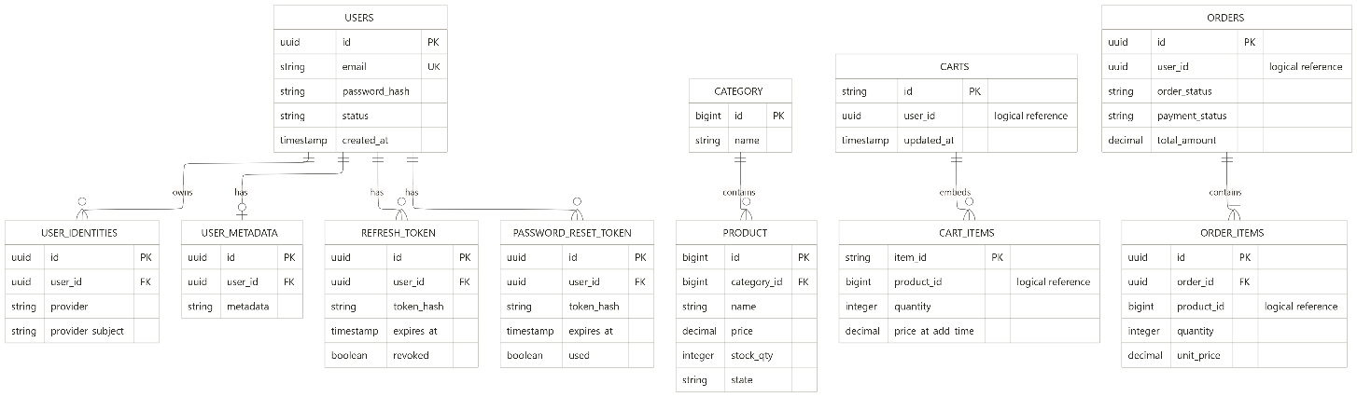

Figure 3.1: Logical entity-relationship diagram across service-owned stores. Foreign-key lines are physical only within the same service database. user_id and product_id in cart, order, and payment stores are logical references because the corresponding authoritative records belong to other services.

3.5 Cardinality of relations
Table 3.5: Cardinality and ownership relationships.
Relationship | Cardinality | Notes
User to UserIdentity | 1 : 0..many | A user may have local credentials and/or one or more external identities
User to UserMetadata | 1 : 0..1 | Implementation-aligned profile/metadata relation
User to RefreshToken | 1 : 0..many | Multiple devices or token rotations may produce multiple records
User to PasswordResetToken | 1 : 0..many | Reset rows are deleted after successful confirmation in the current implementation
Category to Product | 1 : 0..many | A product belongs to one category
User to active Cart | 1 : 0..1 | Enforced by application behavior; cart is a MongoDB document
Cart to CartItem | 1 : 0..many | Cart items are embedded in the cart document
User to Order | 1 : 0..many | User ID is carried into order_db as a cross-service identifier
Order to OrderItem | 1 : 1..many | An order is made of line-item snapshots
Order to PaymentTransaction | 1 : 0..1 in current simple model | Production evolution should permit multiple payment attempts/refunds
Order to ShipmentTracking | 1 : 0..many | Planned relationship; only status patch is currently implemented
Product to Elasticsearch document | 1 : 0..1 derived document | Search projection can be delayed or unavailable

4. Feature Development Process
4.1 Selected feature: secure password reset
Password reset is selected as the key feature because it demonstrates a complete backend capability: REST validation, service-layer rules, persistent security state, Kafka event publication, asynchronous notification, token lifecycle management, and automated tests. It also demonstrates a security requirement that is easy to implement incorrectly: the reset token must not be stored as raw text in the database.
The feature has two phases:
- Reset request: the user submits an email address and, if that user exists, receives a reset link.
- Reset confirmation: the user submits the reset token and a new password; the service validates the token and updates the credential.
4.2 API contract
Table 4.1: Password-reset API contract.
Stage | Method and route | Typical request | Successful result
Request reset | POST /user-mgmt/api/v1/password/reset | { "email": "user@example.com" } | HTTP 202; for existing account, reset event is published
Confirm reset | POST /user-mgmt/api/v1/password/confirm | { "token": "raw-token-from-link", "newPassword": "..." } | Password hash updated; reset rows deleted for user

The request-reset endpoint deliberately returns success for an unknown email as well. This prevents account enumeration, where an attacker tries many emails to discover which people have accounts.

4.3 Request flow and MVC implementation
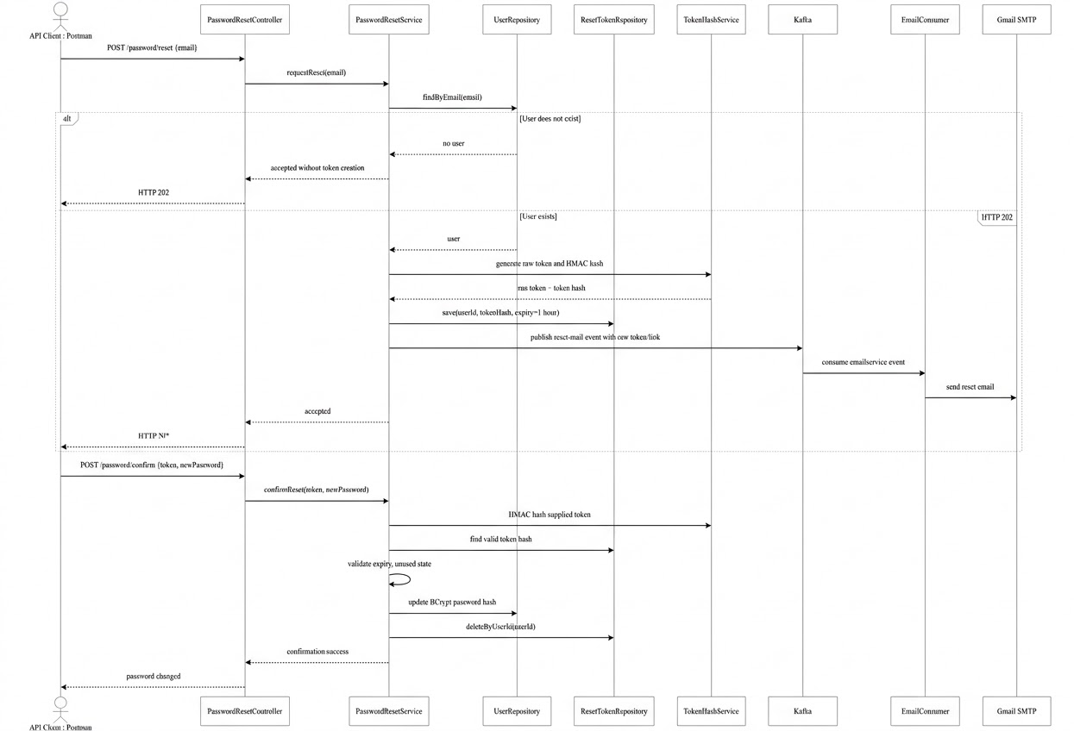

Figure 4.1: Password-reset request and confirmation sequence. The raw reset token exists in the delivered link and request only; PostgreSQL stores an HMAC hash and expiry metadata.
The MVC path is as follows:
- PasswordResetController receives and validates the JSON request.
- PasswordResetService.requestReset applies business rules.
- UserRepository retrieves the user by email.
- TokenHashService produces an HMAC-SHA256 representation of the secret value.
- PasswordResetToken is persisted through the reset-token repository.
- EmailSender or equivalent event publisher sends a message to Kafka topic emailservice.
- EmailConsumer in the Email Service receives the event, records an attempt, and sends the mail through Gmail SMTP.
- During confirmation, the service validates the incoming token hash, expiration, and use status; then updates the BCrypt password hash and deletes reset rows for that user.
4.4 Security and correctness controls
Table 4.2: Password-reset validation and security controls.
Control | Reason | Implementation behaviour
No raw password storage | Prevent credential disclosure | Password uses BCrypt hash
No raw reset-token storage | Limit impact of database exposure | Reset token uses HMAC-SHA256 hash before persistence
Token expiry | Limit abuse window | Reset token expires after 3600 seconds / one hour
Single-use behavior | Prevent link replay | Used/invalid tokens are rejected; successful confirmation removes reset rows
Unknown-email neutrality | Prevent account enumeration | Unknown email returns accepted response without creating a token
Input validation | Reject malformed requests early | Controller tests validate request handling
Asynchronous mail | Avoid blocking the request on email-provider latency | Kafka event triggers Email Service delivery
Token cleanup | Reduce retained sensitive state | deleteByUserId runs after successful password update

4.5 Testing through Postman
A complete manual test sequence can be run without a frontend:
- Register a test user using POST /user-mgmt/api/v1/users.
- Log in with the original password and verify a token response.
- Call POST /user-mgmt/api/v1/password/reset using the test email.
- Confirm that the reset event or notification log exists in the local development environment.
- Use the reset token from the controlled test mail/link in POST /user-mgmt/api/v1/password/confirm.
- Log in with the new password and verify successful authentication.
- Verify the old password fails.
- Verify the reset token cannot be reused.
The repository also includes automated tests for known user, unknown user, blank token, unknown token, expired token, controller validation, and email publication behavior.
4.6 Performance and optimization assessment
The feature's primary optimization target is not a fabricated response-time number; no benchmark artifact in the repository establishes a before/after millisecond result. The documented improvements are architectural and security-oriented:
- The password-reset HTTP request does not wait for SMTP delivery because mail is sent asynchronously through Kafka.
- HMAC lookup uses a fixed-size derived token representation rather than storing or scanning raw secret text.
- Reset rows are deleted after successful completion, reducing long-lived sensitive records.
- Unknown users return immediately without token generation, database insertion, or email publication.
- Test environments disable Kafka listener auto-start where an embedded broker is unnecessary, making service tests faster and more isolated.
For a future quantified benchmark, record p50, p95, and p99 latency for POST /password/reset under three conditions: direct synchronous SMTP, Kafka publication with consumer mail delivery, and a simulated unavailable mail server. The expected engineering result is that the asynchronous design keeps reset-request latency largely independent of SMTP latency, while email delivery becomes eventually consistent.

5. Deployment Flow
5.1 Current local runtime
The currently implemented development topology runs data infrastructure locally, commonly in Docker, while Spring Boot services run on local ports. The email service additionally includes a Compose configuration with an isolated PostgreSQL container.
Table 5.1: Runtime components and ports.
Component | Port | Persistence or integration
Eureka Service Discovery | 9001 | Discovery server, business-service registration
User Service | 9002 | PostgreSQL user_db, Kafka
Product Catalog Service | 9004 | PostgreSQL product_catalog, Elasticsearch
Cart Service | 9005 | MongoDB cart_db, Redis
Order Service | 9006 | PostgreSQL order_db, Kafka
Payment Service | 9007 | PostgreSQL payment_db, Stripe/Razorpay, Kafka
Email Service | 9008 | PostgreSQL notification_db, Kafka, Gmail SMTP
PostgreSQL | 5432 | Structured data stores
MongoDB | 27017 | Cart documents
Redis | 6379 | Fast cart support
Kafka | 9092 | Event broker
Elasticsearch | 9200 | Product search index

Flowchart LR
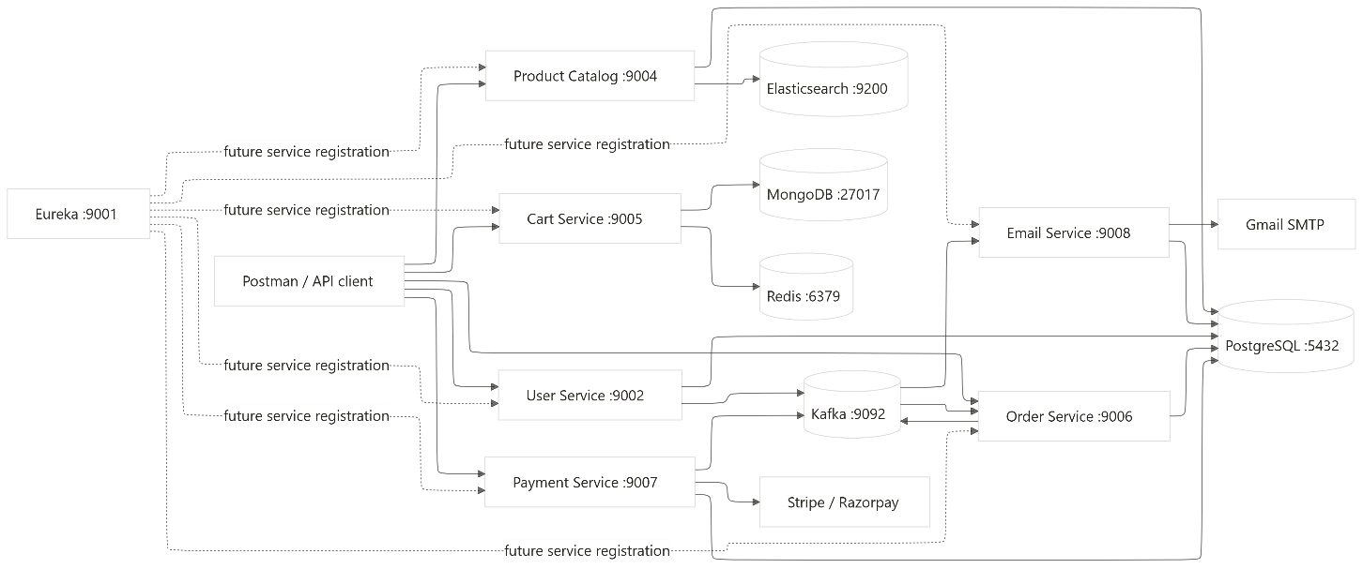
Figure 5.1: Current local deployment and event flow. Clients currently call individual service ports directly. The PRD's AWS ELB and Kong API Gateway remain planned edge components rather than deployed runtime components.
5.2 Planned AWS production architecture
A production deployment can evolve from the current local design without changing the domain boundaries:
- Create a VPC with public subnets for an Application Load Balancer and private subnets for compute and data services.
- Place an Application Load Balancer in public subnets.
- Deploy Kong or a managed API gateway behind the load balancer as the single public API entry point.
- Deploy each Spring Boot service on EC2 Auto Scaling Groups, ECS, Elastic Beanstalk, or Kubernetes in private subnets.
- Move relational databases to Amazon RDS for PostgreSQL, with separate databases or schemas governed by service ownership.
- Use Amazon ElastiCache for Redis.
- Use Amazon MSK or a managed Kafka-compatible platform for Kafka.
- Use Amazon OpenSearch Service or a managed Elasticsearch-compatible deployment for product search.
- Replace local Gmail SMTP credentials with Amazon SES and a secret-management system.
- Store JWT_SECRET, token hash secret, database credentials, provider webhook credentials, and mail credentials in AWS Secrets Manager or another controlled secret store.
The report must clearly state that these are target deployment recommendations. They are not claimed as completed deployment work in the current repository.

6. Technologies Used
Table 5.2: Technology stack and project usage.
Technology | Project use | Practical value in this project
Java 17 | Core implementation language | Stable modern Java language/runtime for Spring Boot services
Spring Boot | Independent backend services | Creates REST APIs, configuration, dependency injection, validation, and service startup
Spring Data JPA | Relational persistence | Maps user, catalog, order, payment, and notification records to PostgreSQL
Spring Security | Authentication and route protection | Protects profile and other private operations; supports bearer-token processing
PostgreSQL | Structured records | Provides transactional storage for user, catalog, order, payment, and notification domains
MongoDB | Cart documents | Fits variable cart-line collections and frequently changing cart state
Redis | Cart-related fast access | Supports low-latency cache/access patterns; caching rules can be extended
Apache Kafka | Event broker | Delivers emailservice, order.placed, and payment.confirmed events asynchronously
Elasticsearch | Product keyword search | Provides fast full-text catalog discovery; PostgreSQL remains source of truth
JWT | Access-token format | Supports stateless short-lived authorization tokens
BCrypt | Password hashing | Avoids storage of raw passwords
HMAC-SHA256 | Secret-token derivation | Hashes stored reset and refresh values so database rows are not replayable tokens
Stripe Java SDK | Payment-provider integration | Initiates provider payment flow and validates webhook flow
Razorpay Java SDK | Payment-provider integration | Offers an additional payment-provider path suited to the project requirement
JavaMail / Gmail SMTP | Email delivery | Sends registration, reset, order, and receipt notifications in development
Maven | Build tool | Builds each service module and manages dependencies
Docker / Docker Compose | Local infrastructure and email service packaging | Runs supporting services consistently during development
Postman | Backend API verification | Executes end-to-end API workflows without requiring a frontend
JUnit and Spring Boot Test | Automated tests | Validates service and controller behavior in isolation

7. Conclusion
The e-commerce platform demonstrates a practical backend microservices implementation. The system separates user identity, product catalog, carts, orders, payments, and notifications into independent services with their own persistence responsibilities. It uses synchronous APIs for operations that require immediate client feedback and Kafka events for work such as email delivery and payment-confirmation reactions that should not delay the original request.
The project demonstrates important applied backend engineering concepts: service decomposition, database-per-service ownership, polyglot persistence, REST API design, JWT authentication, BCrypt password hashing, HMAC-protected reset and refresh secrets, event-driven communication, search indexing, payment webhook verification, and API-level testing through Postman.
The implementation is functionally meaningful but is not presented as a fully production-complete storefront. The major future improvements are a deployed API gateway and load balancer, service registration with Eureka or equivalent discovery, centralized observability, idempotent Kafka consumers, retry/dead-letter handling, transactional outbox publishing, carrier-grade shipment tracking, production secret management, AWS-managed infrastructure, and alignment of all modules on a common Spring Boot version.

References
- Project Requirements and High-Level Design, PRD - HLD of Ecommerce Website, project repository, accessed 1 September 2026.
- Project implementation report, Ecommerce Platform / capstone-project-nxt-sumit-ecommerce.md, project repository, accessed 24 September 2026.
- Spring Boot Documentation, Spring, accessed 3 September 2026, https://docs.spring.io/spring-boot/
- Spring for Apache Kafka Reference Documentation, Spring, accessed 10 September 2026, https://docs.spring.io/spring-kafka/reference/
- PostgreSQL Documentation, PostgreSQL Global Development Group, accessed 2 September 2026, https://www.postgresql.org/docs/
- MongoDB Manual, MongoDB, accessed 5 September 2026, https://www.mongodb.com/docs/manual/
- Redis Documentation, Redis, accessed 8 September 2026, https://redis.io/docs/
- Elasticsearch Reference, Elastic, accessed 12 September 2026, https://www.elastic.co/guide/en/elasticsearch/reference/current/
- RFC 7519, JSON Web Token (JWT), IETF, accessed 6 September 2026, https://www.rfc-editor.org/rfc/rfc7519
- Stripe Documentation, Stripe, accessed 18 September 2026, https://docs.stripe.com/
- Razorpay Documentation, Razorpay, accessed 19 September 2026, https://razorpay.com/docs/

